We are excited about your interest in OrthoBanc!

For questions or to request a free demonstration,
please contact your Sales Representative!

East of the Mississippi River

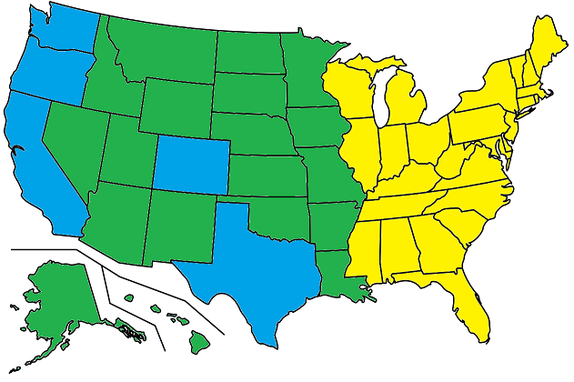
Contact Amy Evans
888-758-0585, ext. 2756
aevans@orthobanc.com

West of the Mississippi River

Contact Glenda Williams
888-758-0585, ext. 8361
gwilliams@orthobanc.com

Contact Holly Gross
888-758-0585, ext. 0726
hgross@orthobanc.com

If additional assistance is needed, please contact our Sales and Support Team at 888-758-0585, option 2 or marketing@orthobanc.com.

